LeetCode Program 7
Link :- https://leetcode.com/problems/reverse-integer/
Successful Submission
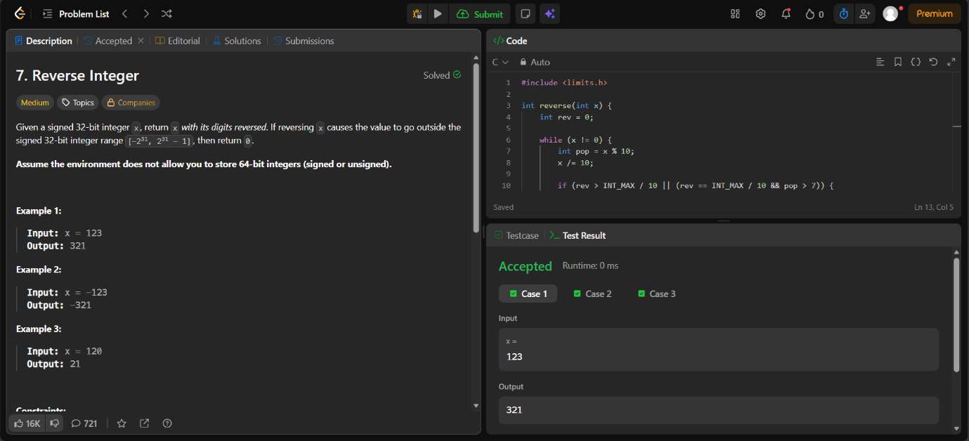
Source Code


